Selection of an NT student to attend the
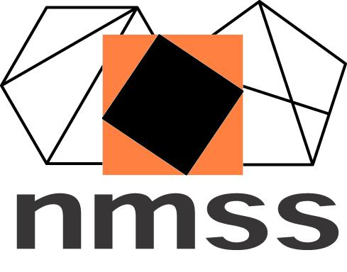
Australian National Mathematics Summer School

The Mathematics Teachers Association of the Northern Territory will fully fund one Year 11 NT student to attend the 2021 Australian National Mathematics Summer School. The two-week residential school will be held at the Australian National University, Canberra on 10th to 23rd January January 2021. It is aimed at talented students of Mathematics who have just completed Year 11.

All students for the National Mathematics Summer School are selected by the Director of the School based on nominations supplied by the State and Territory mathematics teacher professional associations. In the NT, this is the Mathematics Teachers’ Association of the Northern Territory (MTANT).

Around 70 students are selected to attend the school each year. States and Territories are represented approximately in proportion to their populations, so there are only one or two places available for NT students. The NT selection is not based on a competition. The MTANT selectors aim to send a list of names of students to the Director where every student on the list is judged to be able to benefit from the school, to contribute to the life of the school, and to gain a lasting academic and social – and perhaps future professional – value from it.

At the National Mathematics Summer School, mathematically gifted and talented students from all over Australia stay together in student accommodation, and participate in lectures and tutorials across a wide range of mathematical topics such as number theory, topology, cryptology, chaos theory and game theory. There is no sense in which the National Mathematics Summer School is a competition or a ‘cram school’.

At the school, there is an emphasis on problem solving: on doing mathematics, not just listening to someone else talking about it. Students spend a considerable amount of time during the school working independently on problems. They need to have persistence and tenacity as the problems require them to critique and construct mathematical arguments, rather than get the ‘answer’.

They will have the opportunity to mix (and bond) with like-minded students from across the country, and also with young people who are involved in various academic mathematical studies.

The MTANT selection process requires students to demonstrate that their mathematical skills and experience sufficiently equip them to cope with and benefit from the mathematical content of the school. It is expected that students would be studying at least one NTCET Stage 1 Mathematics course (Pre-Methods, or Pre-Methods and Pre-Specialist) or IB Mathematics SL or IB Mathematics HL in Year 11, and intending to study NTCET Stage 2 Mathematical Methods and preferably, NTCET Stage 2 Specialist Mathematics, or IB Mathematics SL or IB Mathematics HL in Year 12.

Students and their teachers are invited to submit other evidence that demonstrates high mathematical ability and achievement. The selectors are also interested in knowing more about students’ involvement in mathematical activities beyond the classroom, particularly where these show the student’s ability and interest to work independently on mathematics, where they have demonstrated sustained interest in a mathematical task, and where they have been involved in extracurricular activities related to mathematics (e.g. Australian Mathematics Trust competitions, MTANT Maths Enrichment Camps, etc.)

More information will soon be available on the NMSS website at http://nmss.edu.au/
Queries to contact.mtant@gmail.com or 0432 676 503. Applications due by Friday 26th June 2020.

